VISION ALIVE & ST. JAMES

2014

Vision Alive is severely damaged by flooding. St. James becomes aware of the orphanage, how Jayne started it and that it was mostly funded by Jayne. The orphanage, at the time, consisted of rough mud and wood structures.

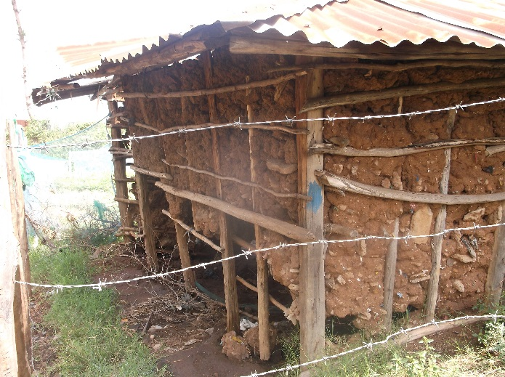

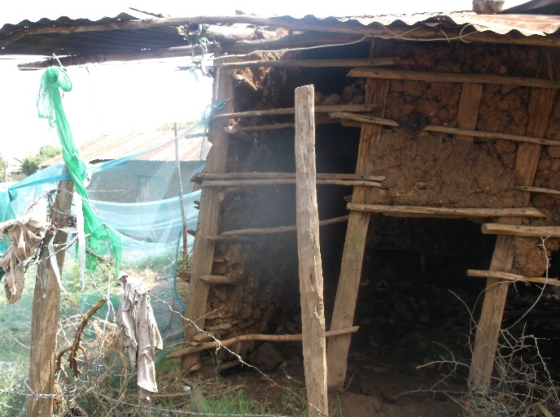

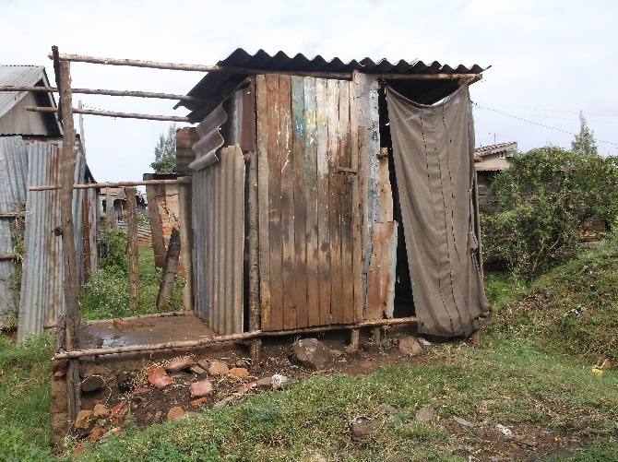

A team from church organized to hold a brunch aimed at raising funds to help with needed repairs. In a short amount of time, more members of the congregation became aware of the needs of the Vision Alive facility and many changes happened. In November of 2014, another breakfast was organized to discuss Global Mission. At this event, the history of global work done by St. James was reviewed and an update on the orphanage was presented. Between these two events, the congregation became very involved in helping Vision Alive. Through contributions from the congregation, as well as others in the community, Vision Alive was able to build new structures, install electricity for basic lighting, build bathroom and shower facilities, and install running water which was not available previously on the site.

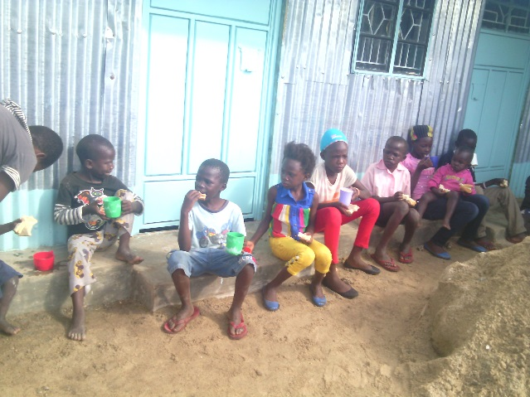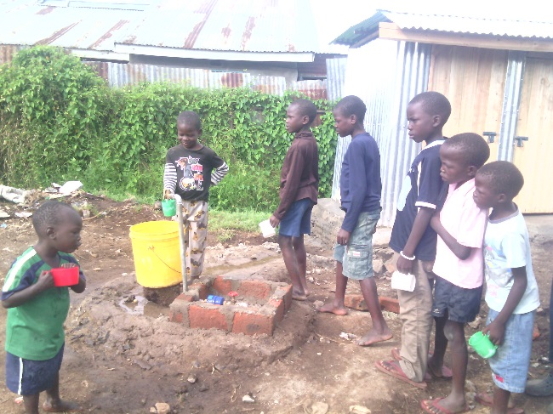
Children Outside the New Buildings Water is added to the facility

2015-2016

Throughout this time, the global mission team worked with Jayne and Vision Alive on many projects. These included farming to grow food for the orphanage and to sell. Raising chickens to sell, this project ended when the chickens became infected and most died. Several collections were done and ‘blue barrels’ were sent to the orphanage with items like dental supplies, clothes, quilts from project comfort, shoes and school supplies.

In 2015, 6 children began attending Joyland day school. By the end of 2016, the global mission team had worked with Jayne and the caretakers at Vision Alive to develop a sponsorship program to support the children in their education. The sponsorship program response was amazing and 29 children began attending Joyland School in Kisumu. This school was a boarding school so the children had housing and meals provided except during school breaks.

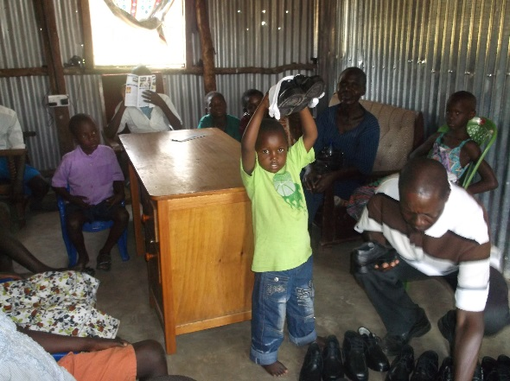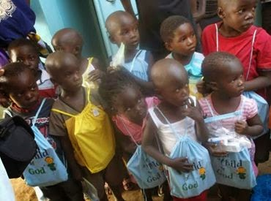

New Shoes Sent School bags and supplies sent

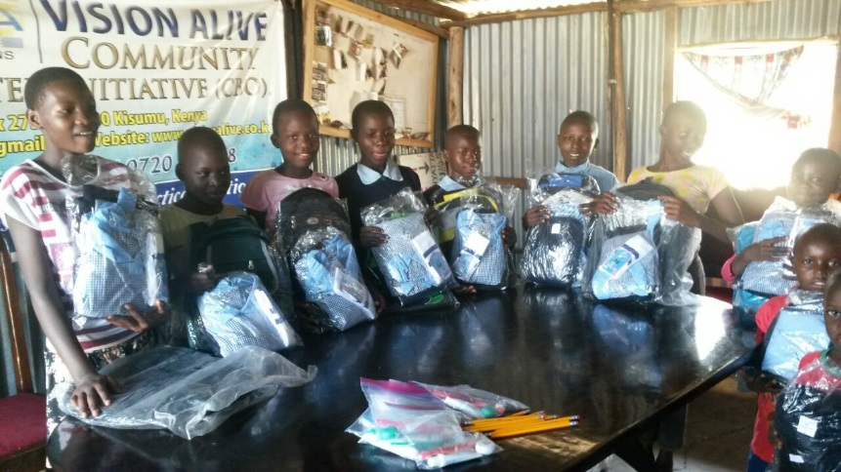

Uniforms for school and school supplies

2017:

Throughout the first year of the orphan sponsorship program, the team became aware of the many costs that had not been considered at the beginning of the program. Items such as toiletries, medicine and medical costs, food needs for breaks, transportation for the children at school breaks and many other items came up through the year. In addition to these unexpected costs, Kenya experienced much political turmoil and spikes in violence in parts of the country. One such area to see a spike in violence and crime was the area of Kisumu where the Vision Alive compound was located. Due to this, the government shut down the facility and children could no longer be housed there.

Through this turmoil, the care takers who assist with the day to day tasks of the Vision Alive children did an outstanding job of helping to house the children during breaks while the global mission team worked with them to update the sponsorship costs.

2018:

St. James presently sponsors 34 children through Vision Alive. The children were enrolled into new schools beginning in the January term. The hope is that the new schools will provide a better education to help the children pass exams to move onto high school.
The Vision Alive children are currently enrolled in new schools beginning in the January term. The hope is that the new schools will provide a better education to help the children pass exams to move onto high school.

Jayne has been working on the beginning phases of building a new orphanage on land located near a new German built and run school. To assist with this project, St. James has begun participating in the Scrip program. The gift cards offered through this program give us the opportunity to raise extra funds to assist with the new orphanage through daily shopping. More information can be found here: LINK

